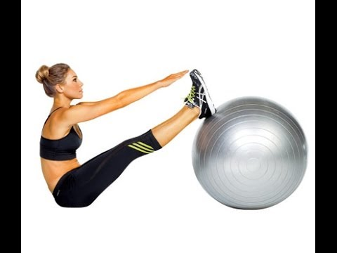
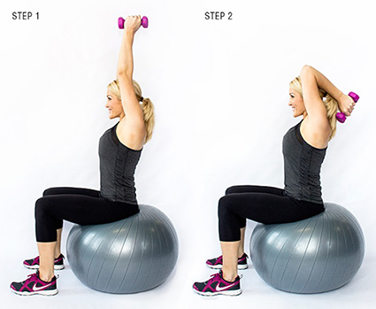
Fitness & Dance

Body Toning Unit

The body toning class is designed to target major and minor muscle groups while incorporating; resistance bands, hand held weights, steps, and stability balls. The specific Health Related components of Fitness that the body toning addresses are muscle endurance, and muscular strength.

Body Toning Description: The body toning class is choreographed movements using resistance bands, hand held weights, steps, and stability balls. With the use of music the movements are choreographed to work major and minor muscle groups. This muscle toning workout is a creative way to work on muscular endurance and strength training. Stretching is a part of the warm-up to prepare the body for more intensity. Flexibility is the ability to move your joints through a full range of motion (ROM).
Benefits of Resistance Training: Resistance training (also called strength training or weight training) is the use of resistance to muscular contraction to build the strength, anaerobic endurance and size of the skeletal muscles.
- Easier performance of daily activities
- Stronger muscles, tendons, bones, and ligaments
- Decreased risk of injury
- Improved posture
Examples of resistance training:
- Free weights- classic strength training tools such as dumbbells
- Your own body weight- can be used for squats, push-ups, planks etc.
- Resistance bands- like giant rubber bands, these provide resistance when stretched. The bands provide continuous resistance throughout a movement
- Stability balls- provide your muscles to work harder while balancing the weight.
- Weight Machines- devices that have weights
Course Objectives: This course is aimed to help each student learn; 1- understand the benefits of health related fitness, 2- understand the safety precautions and injury preventions with strength training, 3- improve general fitness levels, 3- muscle movement correlation.
Task Skill Assessment: Students will choreograph, teach and perform a body toning routine. Students will be assessed on their demonstration of skill, aesthetic performance, and teaching ability.

