TRENDING NOW!
“I’D RATHER BE @ DANCE FITNESS CLASS”
It’s clear there is a growing trend towards a new variety of Dance-Fitness Style workout classes being offered in 2015. At Hampton Bays High School, we are setting trends and offering an inspiring Fitness and Dance curriculum comprised of over 10 different units that deliver the ultimate combination of dance party style fitness.
“Dancing keeps you interested in exercise. If you love your workout you will stick with it”

Whether it’s Zumba or Hip-Hop, dancing makes exercising fun! As such, I have created a unique Fitness and Dance curriculum at Hampton Bays High School that combines key components of both. These units include; Step-Cardio, Dance-Cardio, Body-Toning, Yoga, Body-Shred, Latin Dance, Zumba, Hip-Hop, Pilates Mat, Cardio-Kick, and Country Line Dancing!
It all started with my love of FITNESS!
As a Physical Education Teacher, teaching has become my energy in life! As I learned how to implement teaching with my love of fitness, I quickly gained an audience of students with overwhelming interest to participate. As my students quickly discovered how much fun exercising could be, I found my true passion in teaching the importance of living a healthy active lifestyle and promoting LIFE-LONG FITNESS!
The Fitness and Dance Curriculum at Hampton Bays provides all students with the opportunity to acquire comprehensive knowledge of dance skills and fitness concepts. Students develop and apply a broad understanding of choreography, dance & fitness elements, and learn a variety of fun training techniques which can be applied towards achieving personal fitness goals. The combination of Fitness and Dance offers both students and instructor a total body workout by using all the major muscle groups which promote additional heart-healthy benefits.

HAMPTON BAYS
FITNESS & DANCE CURRICULUM
The best part about this unique curriculum, both the class instructor and student reaps numerous health benefits, all while participating in a full filled group workout experience! Where would you rather be?
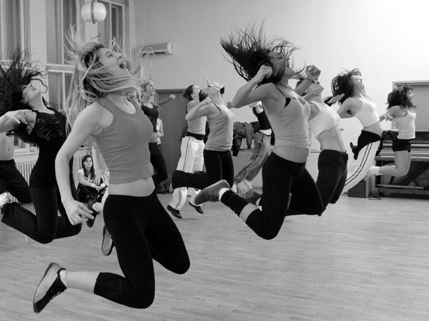
At HB, students are given the option to select the Fitness and Dance Program as part of their Physical Education requirement. They learn how to salsa, they experience the cutting edge of hip-hop style moves, and students discover their inner balance during yoga. Offering the most fun you will ever have while exercising!
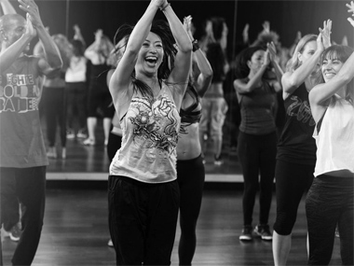
Dance Fitness is on the rise with its new trending classes such as pound fitness, ballet-barre, crossfit, trampoline fitness and so much more!
FITNESS can be FUN! Inspire
Amy Stangasser; Author, Creator, and Director of Hampton Bays Fitness and Dance Curriculum Design

