Flag Football Study Guide
● If a ball that is passed is not caught, the line of scrimmage does not move forward and all players must return to the same spot they were in before for the next play.

● A snap of the ball is moving the ball from the ground to the quarterback.

● In order to legally stop the ball carrier from gaining more yards, one must pull the flag off the person who has possession of the ball.

● Each player performs the quarterback and the center positions.

● Tackling and diving for your opponent’s flag is not permitted.

● All players are eligible pass receivers.

● An opposing player that jumps across the line of scrimmage before the snap of the ball is considered offside. (Penalty is 5 yards)

● Once the ball is moved in front of the line of scrimmage, the ball carrier CANNOT pass it forward to a different teammate.

● If the ball is dropped the play is considered a fumble and ball is NOT LIVE; therefore the ball CANNOT be picked up to continue that play. The ball is considered to be DEAD.

● The neutral zone is the line of scrimmage equal to about one length of the football.

● Opposing players CANNOT wait for the next play on either side of the line of scrimmage. They must return to their team's side to line up.

● If the ball changes hands while it is still behind the line of scrimmage, the defensive team may NOT rush the carrier of the ball until “4 Mississippi” has been called.

● Screen-blocking an opponent is the only type of blocking allowed; a force full push is not allowed.

● Shielding your own flag from defenders is illegal.

● Defense is when the team that is not in possession of the ball and they are protecting the end zone.

● A dead ball is an incomplete pass, a fumble, or when the ball carrier’s flag becomes detached.

● The end zone is the area between the goal line and the end line where touchdowns are scored.

● The quarterback is an offensive player who usually receives the snap and throws or runs with the ball.

● When a player is offsides that means there was movement across the line of scrimmage before the ball is snapped.
- An interception is when the defensive team catches the ball that was meant for the offensive

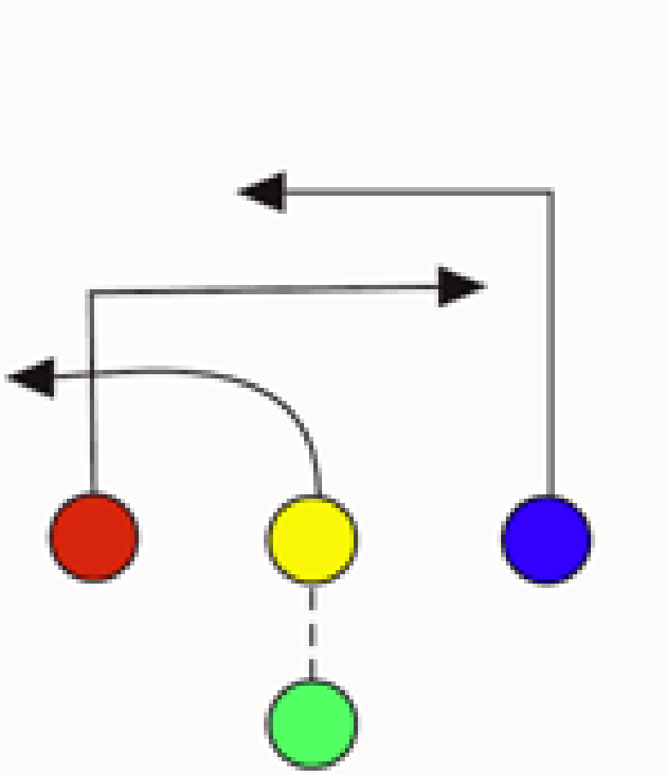
Number 4 represents the quarterback position in the following diagram
Number 2 represents the center position
2

4

Pass routes
