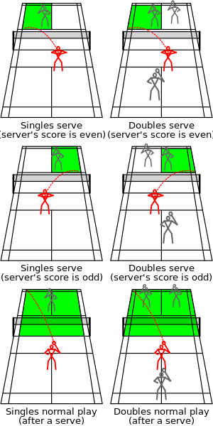
BADMINTON SERVICE ROTATION FOR
SINGLES AND DOUBLES

