Pilates Syllabus
Hampton Bays PE
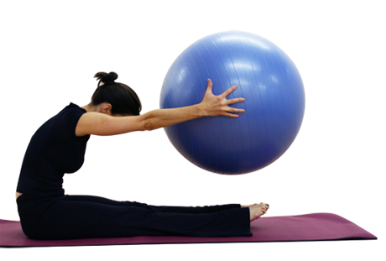
Using props in a Pilates mat class can work wonders for increasing strength, flexibility and correcting improper biomechanics. For example, a small ball between the knees engages the adductors and helps to stabilize the pelvis and engage the core. A yoga strap is a tool for deeper stretching, a theraball challenges balance and stability and a yoga block may be used to open the joints and is used as a stability tool when placed under the pelvis. The props are utilized to prop or position the body so you can feel the origin of the muscle, using a muscles full length when extending and retracting!

Course Description
This course is designed to improve muscular strength, endurance, flexibility, posture, balance, and relaxation techniques. Students will be provided with a working knowledge of Pilates positions, the benefits associated with Pilates, and knowledge of skills needed to pursue independent training as part of their lifetime fitness program.

Course Objectives
The student will be able to:
1. improve muscular strength, endurance, flexibility, balance, and overall joint mobility.
2. demonstrate an intermediate working knowledge of Pilates positions and theory as well as discuss the benefits associated with Pilates.
3. summarize, critique, and formulate lifestyle behaviors and nutritional choices that will contribute to a healthy lifetime fitness and wellness program

Upon completion of this course, the student will be able to:
1. Demonstrate knowledge of the characteristics of the Pilates Mat program as a
fitness tool.
2. Gain knowledge through application of Pilates Mat, body rolling, ball extentions, and thera-band exercises.
3. Physically demonstrate Pilates vocabulary.
4. Demonstrate ability to integrate Pilates principles into everyday movement and
activities.
5. Develop analytical and critical skills through self-evaluation and observation.

