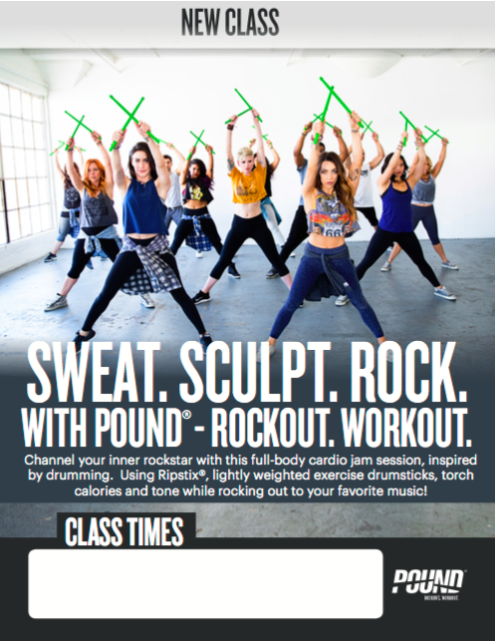
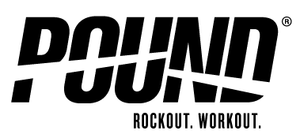
Hampton Bays Fitness & Dance
Pound Fitness Syllabus

Task: Students will choreograph a pound fitness routine within a small group setting. Utilizing the correct pound positions; standing, sitting, lying supine and/or lunging. (set position, KIT position, T&G, and Lunge positions). Students will teach and demonstrate the proper form of the movements and instruct pound fitness routines to their peers. Students will: 1-demonstrate the correct movement forms and show safety modification, 2-verbal and nonverbal cueing for transitions, and show proper knowledge for aesthetic performance during instruction-timing and rhythm.

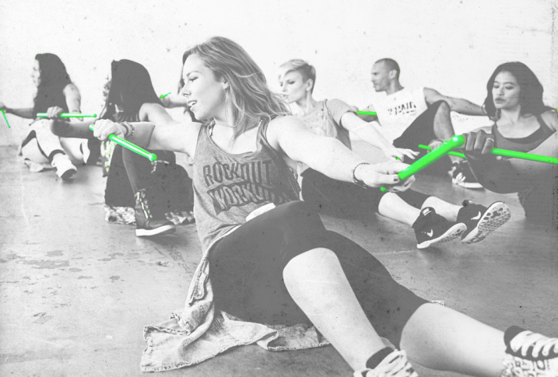
POUND CLASS
Instead of listening to music, you become the music in
This exhilarating full-body workout that combines
Cardio, conditioning, and strength training with yoga
And pilates-inspired movements.

Designed for all fitness levels, POUND® provides the
perfect atmosphere for letting loose, getting energized,
toning up and rockin’ out! The workout is easily
modifiable and the alternative vibe and welcoming
philosophy appeals to men and women of all ages
and abilities.

THE BENEFITS
- Burn up to 900+ calories per hour, strengthen and sculpt infrequently used muscles, and drum your way to a leaner, slimmer physique – all while rocking out to your favorite music!
- Drastically improve your rhythm, timing, coordination, speed, agility, endurance, and musicality.
- Cinch the waistline, slim the thighs, and strengthen connective tissue and infrastructural muscles with the combination of stability and cardio.
- Numerous studies have proven the powerful brain boosting, stress-relieving effects of drumming. The rhythm of drumming permeates the entire brain to improve focus, increase higher-level thinking and decision-making skills, boost the immune system, lower blood pressure, decrease chronic pain, anxiety, and fatigue.

WHY IT WORKS
Instead of counting reps or keeping track of the clock, POUND® strategically distracts you from the high-intensity and duration of your workout, and shifts your focus to rhythm and volume. This strategic distraction is responsible for the "addictiveness" of POUND® - the reason you can't stay away!

Each 2-4 minute song is carefully calibrated with interval peaks and extended fat burning sequences, providing you with the best workout in the shortest span of time. After you’re done rocking out in a 45-minute POUND class, you’ll have completed up to 15,000 reps, performed over 30 extended interval peaks, and zipped through more than 70 techniques without even realizing it.

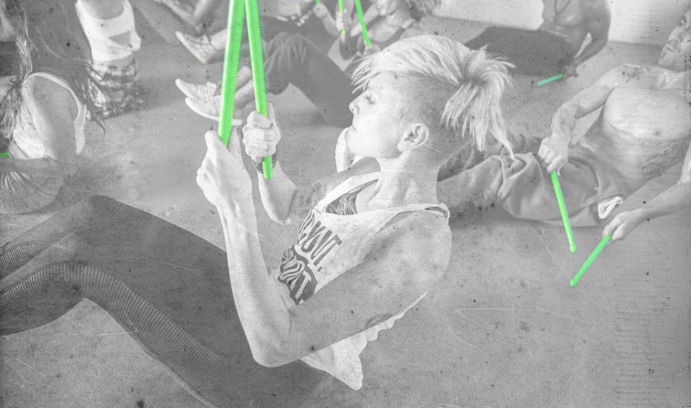

RIPSTIX
They have invented unique, lightly weighted exercise drumsticks called Ripstix®.
- Ripstix® add 1/4 lb extra weight to each movement which throws the body off balance, creating contraction in the core and stabilization system.
- Ripstix® intensify each POUND® position with light, peripheral resistance that not only works the shoulders, biceps, triceps, forearms, and back, but also dramatically increases the amount of instability in the body.
- Ripstix® allow participants to experience audio-muscular connection. This means they can hear what their muscles are doing.
- They’re made of durable plastic and are easily transportable - and can go through airport security — so you can take your Ripstix® anywhere!

BENEFITS
Cardio- Large, rhythmic movements comprise our workout bass line making POUND® optimal for building aerobic fitness. Additionally, moments of intense intervals and explosive movements allow you to improve your anaerobic capacity. POUND® is a cardio challenge hidden by motivating and electric music as well as the fun of drumming.
Strength- Squat, lunge, twist and lift your way to a stronger and leaner physique. Deep, focused movements build muscular strength and enhance muscle definition. In addition, exposure to a multitude of movements and strike patterns ups your neuro-muscular feedback loop aiding in strength gains.
Flexibility- POUND®’s techniques progress you purposefully through 360-degrees of movement allowing you to increase your joint range of motion over time.
Benefits- Balance and core strength! Ripstix® combined with POUND® techniques keep the body consistently adapting to a shifting center of gravity throughout the workout. Over time your core will strengthen and your balance will improve as a response to the demands of the workout.
Pound Choreography- When Choreographing a routine you will need to do 4 specific tasks.
P – Stands for more than 2 pound strikes to the ground
- Write the name of the skill movement (in the middle of the circle)
- Write the number of 8 counts (top of the circle)
- Use a line symbol to indicate how many taps (bottom of the circle)
- Use 2 lines to the right of the circle to show a quick double time
8
NAME
4
NAME

P

