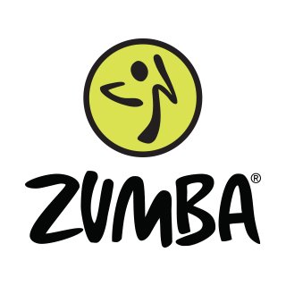
ZUMBA FITNESS UNIT

What is Zumba?
Zumba Fitness is a Latin-inspired cardio-dance workout that uses music and choreographed steps to form a fitness party atmosphere. While many of the types of dance and music featured in the program are Latin American inspired, classes can also contain everything from jazz to African beats to country to hip-hop and pop.
Course Description:
Students will participate in an aerobic format Latin style dance designed for cardiovascular development, muscle toning and flexibility. The Zumba Fitness Unit teaches easy to follow steps/movements and choreographed routines displaying the basic Latin dance rhythms (salsa, merengue, cumbia, reggaeton, and bachata) for total body conditioning.
Course Objectives:
By the end of this course students will be able to participate in a variety of Latin based choreographed dances to create an interval workout to improve their fitness and allow them to improve/maintain their cardiovascular levels and improve/ maintain body composition. Students will especially develop muscle memory in their core area in order to use the core muscles to burn fat in their workout.
Class Format:
- Warm-up- consists of routines with easy movements to stretch the body and prepare the muscles for greater range of motion.
- Cardio- 3 routines in a row to build the movements to achieve cardiovascular fitness level of low and high impact movements.
- Cool down- consists of a stretching routine designed to increase flexibility and bring the heart rate back to a normal state.
Course Outcomes and Objectives: Student Learning Outcomes: The student will;
- Improve their cardiovascular system through aerobic exercise.
- Identify ways to increase muscle strength, tone and flexibility.
- Demonstrate a knowledge of latin dance steps and movements.
- Gain an understanding of the long term benefits of aerobic exercise.
- Understand how to take and monitor heart rates while participating in an aerobic activity.
- Understand the basic rhythms through participation and their synthesis level through the demonstration of a basic routine.
Task: Students will create and perform a zumba routine in a small group setting. Students will be given time to choreograph a zumba routine to music utilizing salsa, merengue, bachata, cumbia etc. Students will teach, demonstrate and perform their choreographed routine. Students will be graded on skill, aesthetic performance, choreography, and performance cuing. Students will also take a written exam and the end of the unit.

